**A SAMPLE OF HISTORY AND POLITICAL ITEMS**

**ITEM 1**

**Read the following scenario and respond to the task that follows.**

**Scenario: Clash of Traditions in Rural Uganda**

In a small, remote village in Eastern Uganda, the majority of villagers practice a traditional Ugandan religion centered on ancestral worship and appeasing spirits for good harvests. However, a Charismatic Pentecostal Pastor has recently arrived and established a church. The Pastor strongly criticizes traditional practices, calling them primitive and demonic. The villagers think these attacks disrespect their ancestors and heritage. Others, caught between their ancestors and the pastor's promises of salvation, become withdrawn and avoid participating in traditional rituals. Villagers who convert to Pentecostalism stop contributing to communal activities centered on traditional beliefs. This strains the social fabric and threatens the future of these cultural practices. The conflict has worsened, leading to arguments, dismissal of converts, and even violence.

**Support Material**

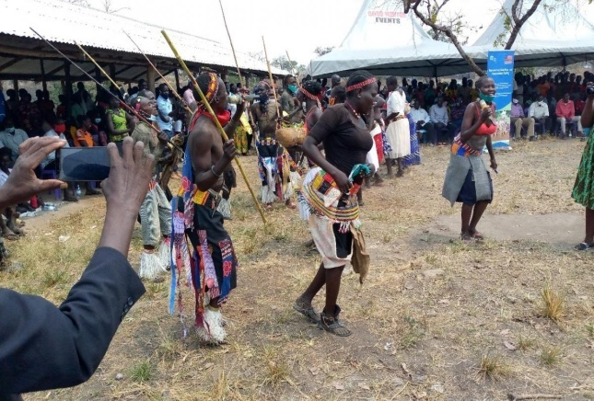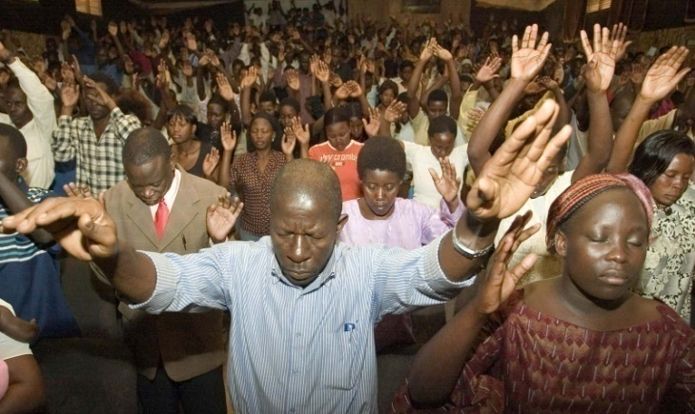

**Task**

You are among the respected villagers called for a meeting on this escalating situation mentioned in the above scenario, explain how best it can be resolved.

**ITEM 2**

**Read the following scenario and respond to the task that follows.**

In Uganda, the development of the structure of government, constitutionalism, and human rights has been a difficult and often unstable journey, shaped by a variety of historical, political, and social factors. In 1962, Uganda gained independence from British colonial rule, and a new era of governance began. Initially, the country adopted a parliamentary system of government, with a prime minister as the head of government and a president as the head of state. However, political instability and conflict soon followed, leading to the rise to power of Idi Amin in 1971. Despite the constitutional changes, Uganda has faced ongoing challenges in the advancement of its governance structure and the protection of human rights. The country has experienced periods of political unrest, suppression of opposition voices, and allegations of electoral irregularities.

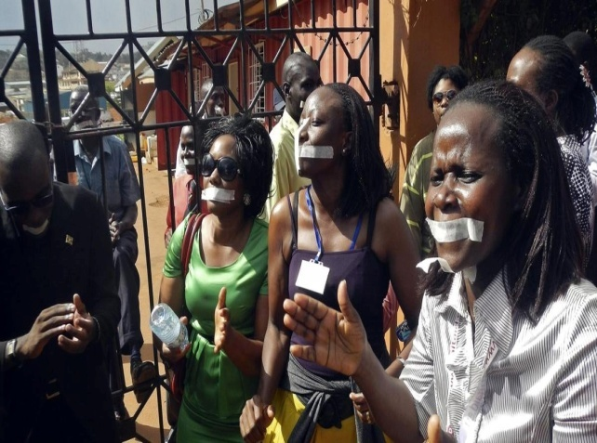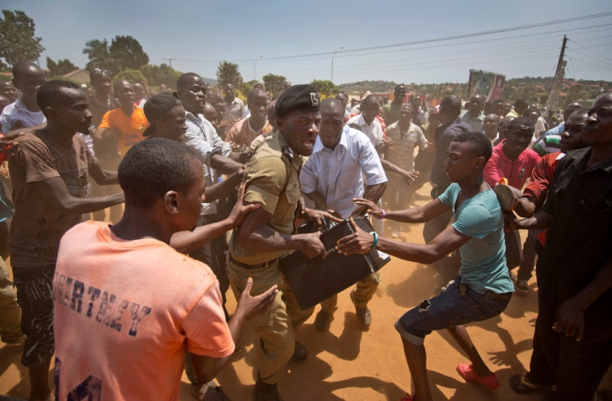

**TASK**

As a student of History and Political Education, write an article on the situation mentioned in the above scenario can be resolved.

**END**